|  |
| --- |
| Airbus Logistik GmbH Organization Manual |
| <SUMMARY_BEGIN>SUMMARY : |
| PURPOSE/SCOPE: |

|  |
| --- |
| The purpose of this Organization Manual is to present the Airbus Logistik GmbH organization framework through the description of each Head of Function’s accountabilities, key missions and organization.  In addition, Airbus main governance bodies are described to provide a clear view on the decision making process for all Production Organization Approval (POA) related activities in Airbus Logistik GmbH.  In scope of this manual are all logistic activities under Airbus Logistik GmbH perimeter. |

|  |  |  |
| --- | --- | --- |
|  | | |
| <SUMMARY_END> | | |
| Document Owner:  Name: VAN HEEL Michael  Function: Head of Airbus Logistik Operations |  | Authorizer for Application:  Name: PETERS Sebastian  Function: Managing Director, Airbus Logistik GmbH |

TABLE OF CONTENTS

1 Introduction 4

2 Operating Model 5

2.1 Organization 5

2.2 List of warehouses 5

2.3 Business Management System Role 5

3 Governance and Reporting 6

3.1 Shareholders Committee for Airbus Logistik GmbH 7

3.2 Airbus Logistik GmbH Executive Leadership Team 7

3.3 Airbus POA Governance and Reporting 7

3.4 Airbus Logistic GmbH – Quality Organization (ALOQ) 8

4 AL – Airbus Logistik GmbH 9

4.1 Managing Director (Geschäftsführer) 9

4.2 Accountabilities and Mission 9

4.3 Organization Chart 9

5 ALO – Operations 10

5.1 Role Purpose 10

5.2 Responsibilities 10

5.3 Deliverables 10

5.4 ALO Organization 10

5.4.1 ALO1 – Planning & Performance 10

5.4.2 ALO2 - Operations Big Parts 11

5.4.3 ALO3 - Operations Small Parts 11

5.4.4 ALO4 - Operations Overseas 12

5.4.5 ALO5 - Operations Material Provision and Transport 12

5.4.6 ALOQ - Quality, Health, Safety and Environment 12

5.5 Organization Chart 13

6 ALA – Airbus Logistik Administration (Head of Administration) 14

6.1 Role Purpose 14

6.2 Accountabilities and Missions 14

6.3 Deliverables 14

6.4 Organization Chart 15

6.5 Interfaces 15

7 Support Functions 16

8 Referenced Documents 17

9 Glossary 17

Appendix A. Airbus Logistik GmbH- Quality Plan for Airbus SAS POA Activities 18

Contributors 19

Record of Revisions 19

# Introduction

Airbus Logistik GmbH is a wholly owned subsidiary of Airbus Operations GmbH with formal governance bodies and regular management meetings between both to ensure business coordination. As a subsidiary Airbus Logistik GmbH has close connections to the parent company Airbus Operations GmbH.

The company was created to build a logistic lighthouse in regaining Airbus know how in logistics, leverage best in class performance on the Final Assembly Line (FAL) Single Aisle (SA) scope and boost competition on the remaining buy-scope.

It is independent from any service provider and has full control of logistics operations for the FAL SA Hamburg as strategic area for Airbus.

# Operating Model

## Organization

Airbus Logistik GmbH (AL) is divided into Airbus Logistik Operations (ALO) and Airbus Logistik Administration (ALA). The accountabilities, scope and detailed organizational charts are described in the respective chapter of this document.

## List of warehouses

The List of warehouses is managed in A10-AL Appendix A - §4

## Business Management System Role

The Airbus Logistik GmbH processes are managed in the frame of the Airbus Business Management System (BMS) by a network of PMT (Process Management Teams) as part of FU.SD.03 process.

For a transition period operational documentation derived from the incumbent logistic service provider is maintained in a dedicated repository until changeover to Airbus BMS standards and upload into the corporate document system.

The detailed link between Airbus BMS, local documentation and the repository is described in A10-AL Appendix A - §3.

# Governance and Reporting

The governance model selected by Airbus relies on the distinction between the management role and supervisory role.

The management role is undertaken by the Executive Leadership Team, which is comprised of:

* The Managing Director of Airbus Logistik GmbH

The Managing Director of Airbus Logistik GmbH reports to the Board of Directors.

* ALA Business Manager covers Finance, Human Resources and central administration.
* Head of Operations covers all logistics operations, planning & performance and Quality.

They are in charge of running the day-to-day activities of the company.

The supervisory role is undertaken by the Shareholders Committee which is composed of representatives from different Airbus Functions.

Members of the Shareholders Committee are:

* Dr. André Walter (Chairman), Speaker of the Board of Management of the Airbus Operations GmbH and Head of Hamburg Plant
* Marco Wagner, HR Director for Airbus Operations GmbH and Head of HR Airbus Commercial Aircraft Germany
* Jörg Klein, Financial Manager Airbus Ops. Germany (reporting to the CFO of Airbus Operations GmbH)
* Martin Böhler, Affiliates Corporate Governance

The Shareholders Committee oversees and advises the Executive Leadership Team on strategic, financial and business topics comprising the overall Airbus Logistik GmbH business perimeter.

The Airbus Policy (A1043) of Corporate Governance for Subsidiaries is applicable to Airbus Logistik GmbH.

## Shareholders Committee for Airbus Logistik GmbH

Airbus Logistik GmbH is a wholly owned (100%) subsidiary of Airbus Operations GmbH.

Airbus Logistik GmbH is formally governed by a Board of Directors

The overall business perimeter of Airbus Logistik GmbH is supervised/advised by a Shareholder Committee, under the leadership of the OA Plant and Industrial Site Hamburg. This Committee has no formal legal role but acts as a kind of advisory committee. Meetings of this Shareholder Committee are planned to be held three to four times a year.

The main matters of the Shareholder Committee are, among other things, the budget, the five-year investment plan and major investment decisions.

## Airbus Logistik GmbH Executive Leadership Team

The Executive Leadership Team is responsible for managing the operations of the Airbus Logistik GmbH businesses.

They must cascade decisions from the Shareholder Committee down to the businesses and functions they lead.

## Airbus POA Governance and Reporting

Links between Airbus Logistik GmbH and Airbus Logistics & Transport (OTT) and organization /Airbus Quality organization in Airbus SAS.

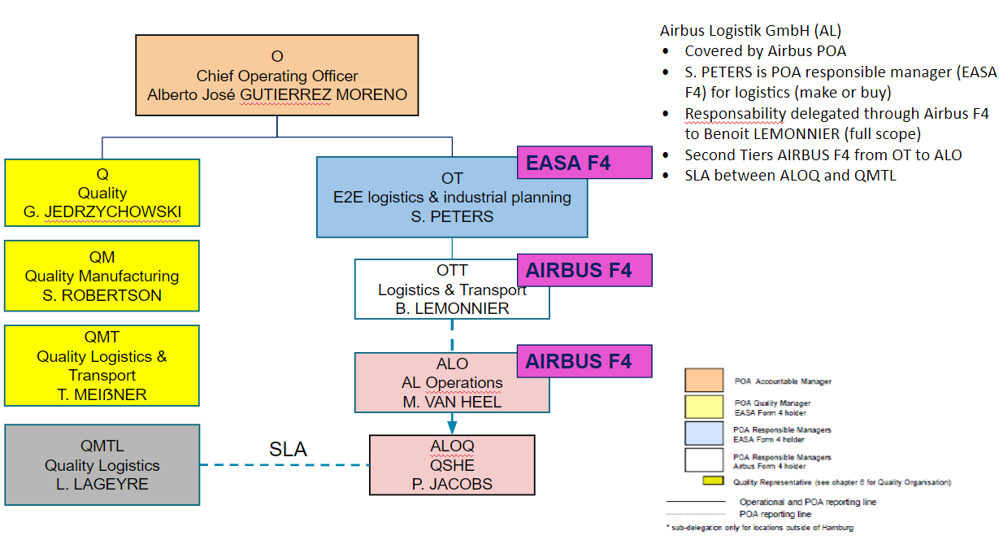

*F4 = EASA Form 4*

*ALOQ = Airbus Logistik GmbH Quality Organization*

As a permanent reminder, please note that all Organization charts presented in this document are only valid as of the publication date (see cover). The actual Airbus reference for Organization charts is the “Org Chart View” software in MyPulse (select "Other Airbus"), accessible from the Airbus Intranet portal (Hub). Only a change in the organization structure will lead to an update of the document.

**POA Responsibilities**

The Head of Airbus Logistics & Transport (OTT) has delegated his POA responsibilities to Airbus Logistik GmbH Head of Operations (ALO) through an Airbus Form 4 as per A30 (POM) chapter 3.2.

**Quality Reporting**

The POA independent monitoring of the POA in Airbus Logistik GmbH is managed by the Head of Quality/Safety/Health/Environment in Airbus Logistik GmbH (ALOQ), reporting functionally (business link) to the Head of Logistics Quality in Airbus SAS (QMTL).

The Head of Logistics Quality in Airbus SAS (QMTL) reports operationally to the POA Quality Manager (QMT) as per A30, chapter 6.1.2.

Organization and way of working between QMTL and ALOQ are described in the SLA ALOQ-QMTL Ref.: CT2102432v1.

## Airbus Logistic GmbH – Quality Organization (ALOQ)

* Limited organization to secure full adherence to Airbus system
* Independent Airbus organization using the Airbus Quality System

**Airbus Logistik GmbH**

**ALOQ**

**QSHE**

**Quality Mgt.**

**Operational**

**Quality**

**Health & Safety, Environment**

A10-Airbus Logistik

Adapting Kühne+Nagel QMS

to Airbus

Quality Key Performance Indicator

(KPI)

Auditor

QA/WA management

Documentation mgt.

Tools & Standards (8D/Practical

Problem Solving (PPS))

Compliance to Requirements (POA)

EN9001/9100 certification

Surveillance (Spot Assessment)

Non Conformance Mgt

Customer Claim

Training

5S Audit

FOD Management

Dangerous Goods

Hazardous Materials

Safety at Work

Training

Administration

ISO14001 certification

Team Mgt. & Development/Perf

Interface QMTL

Quality Objective & Target

EASA Local coordinator (R18 role as per A30 Appendix E)

QAST role

Auditor

Audit planning

# AL – Airbus Logistik GmbH

## Managing Director (Geschäftsführer)

Airbus Logistik is headed by the Managing Director (Geschäftsführer), who manages, leads and represents Airbus Logistik GmbH in accordance with the rules established by the Shareholder Meeting. The Managing Director brings Airbus Logistik matters before the Shareholder Meeting.

The Managing Director chairs the Airbus Logistik Executive Leadership Team and is responsible, together with the leadership team, for the overall businesses of the Airbus Logistik GmbH.

## Accountabilities and Mission

The Managing Director has the overall accountability for the Airbus Logistik business.

Particularly Airbus Logistik Managing Director is accountable for:

* Formulation and implementation of the Airbus Logistik strategy, including without limitation the Business Plan and the Operational Plan
* Company policies, management and organizational structure
* Financial performance and financial targets
* Management of shareholder relations and corporate matters

## Organization Chart

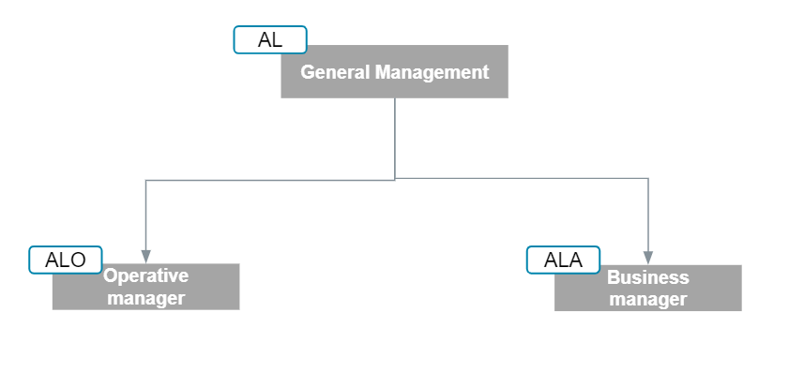

See “Org Chart view” in MyPulse

# ALO – Operations

## Role Purpose

The head of operations is accountable for all logistic and transport operations in Airbus Logistik GmbH warehouses.

## Responsibilities

* POA responsibility by delegation from Head of OTT for Airbus Logistik GmbH scope
* Delivering logistic services on cost, quality and time to customers
* Build strong relationships with relevant Airbus peers to ensure Airbus Logistik Operations meets the need of Airbus as a customer
* Responsibility for development and deployment of new logistic processes
* Overall responsibility for Health and Safety matters

## Deliverables

SLA ALOQ-QMTL CT2102432v1

## ALO Organization

The Airbus Logistik Operations consists of below organizational entities:

* ALO1: Planning & Performance
* ALO2: Operations Big Parts
* ALO3: Operations Small Parts
* ALO4: Operations Overseas
* ALO5: Operations Material Provision
* ALOQ: Quality, Health, Safety and Environment

Their scope of activity and purpose is described in the following chapters.

### ALO1 – Planning & Performance

Central planning & engineering department is responsible for the central planning of logistics processes as well as implementation of continuous improvement projects and innovation projects, engineering changes. Through creation and maintenance of standard operating procedures they set standards and ensure process compliance in the Airbus Logistik GmbH. An IT process engineer serves as a central focal point for IT-related topics and sets the focus on continuous improvement in the logistics IT environment. The IT process engineer also represents the central interface between the Airbus Logistik GmbH and the central IT department of Airbus Operations.

Customer support is the central interface to the customer, the SA FAL Hamburg and OSLAL. Utilizing various tools for data analysis they have the transparency on the current order status of materials in the intralogistics process from goods receipt to material provision at the FAL. Through proactive monitoring of the status of each MSN they identify risks and deviations before they have an impact on production and define counter measures in alignment with the FAL. Customer support also initiates and tracks the counter measures in operations. With this transparency they are capable to review and assess tactical re-planning of the FAL from a logistics perspective, identify consequences and propose feasible alternatives.

Performance management is responsible to provide the right and correct data for operational data-based performance management to operations and the management of Airbus Logistik Gmbh. This includes volume KPIs (e.g. Forecasts, WIP, Processed Volumes), current work progress, Productivity KPIs, and Service KPIs. In this position, they develop management  and operational KPIs for teamboards, dashboards, and reportings. In addition, they monitor operational KPIs to identify inefficiencies, bottlenecks, and disruptions and propose solution options to operations.

Operative service is responsible for all administrative tasks related with daily operations. Activities include time management, operative procurement, Invoice control, coordination of facility management and maintenance activities.

### ALO2 - Operations Big Parts

Operations Big Parts is characterized by a process-oriented organization structure. It is responsible for physical logistics of mainly big parts for the FAL SA scope. The organization covers the warehouses CEC1, CEC2 and DC7B, and is split into inbound, warehousing and dispatch. The inbound department includes all operational and administrative functions in the inbound / goods receiving process - mainly in CEC1.

Warehousing incorporates putaway, picking and commissioning activities in CEC1 as well as all logistics activities in CEC2 and DC7C.

Dispatch covers all outbound logistics activities for the dispatch to external locations (e.g. Airbus Toulouse, returns to external suppliers, etc.).

### ALO3 - Operations Small Parts

Operations Small Parts includes inbound and warehousing functions of small parts for the FAL SA scope. The organization covers the warehouse DC7C.

The inbound department includes all operational and administrative functions in the inbound / goods receiving process of DC7C.

Warehousing incorporates put away, picking and commissioning activities in DC7C.

### ALO4 - Operations Overseas

Operations Overseas serves as a cross-dock function for the scope of FAL China and FAL USA. Today, Overseas Operations are performed in GU1 warehouse.

The main activities are kitting/packaging & preparation for transport to China and USA, preparation of transport documents (customs, DG), and material handling incl. goods receipt of secondary flows and inbound of empties returns.

In addition, operations in GU1 today cover the supply of fasteners to the FAL, storage of Aircraft Center Tank (ACT) units and inbound and dispatch of sharklets.

### ALO5 - Operations Material Provision and Transport

ALO5 includes all physical logistics processes to provide the required materials at the point of delivery / point of use, starting from loading at the warehouses to material provision at the FAL. The organization is characterized by a process-oriented structure.

The Transport organization is responsible for all transport activities between the warehouses and the FAL, starting from pick-up of prepared delivery units at the warehouses.

Inbound FAL is responsible for all physical inbound processes (inbound from warehouses, direct deliveries from suppliers, InterNatco flows, and inhouse materials).

Module creation is mainly responsible for the process of consolidation of handling units and preparing them for material provision. The finished handling units are then buffered in the marketplace.

The material provision unit is responsible for the timely delivery of materials in the right quantity to the correct point of use, triggered by the pull signal from the FAL. Due to the physical connection of lines 1-3 and their direct link to the marketplace in H14, module creation and material provision of lines 1-3 are served by one organizational entity.

Due to the larger distance of line 4 and the outstanding work parties, they are served by an individual department, which also incorporates the onsite transport from H14 to the point of delivery.

### ALOQ - Quality, Health, Safety and Environment

Quality, Health, Safety and Environment manage all quality and POA relevant activities and coordinate the Health, Safety and Environment topics for Airbus Logistik.

**Role Purpose**

* Deploy the required and applicable quality standards, processes and procedures
* Develop and sustain the Company Management System fulfilling International Standards for Safety and Aviation Authorities Requirements
* ALOQ works in partnership with the Heads of the Operational Business Units and is accountable for Quality of the deliverables within their respective business.

**Main Accountabilities**

* ALOQ is maintaining a strong interface by SLA to Airbus Quality Logistics (QMTL)
* Ensure that all organizations performing Airbus POA and quality activities, follow the applicable Airbus rules and procedures, which are referred in the A30 POM and the Appendix A of this document. This includes surveillance and internal audits in warehouses listed in A30_Appendix C as per applicable POM Chapter.
* Ensures a direct link to Airbus Form 4 holder (referenced in A30_Appendix E) and the Quality function
* Improve the collaboration between the Quality and Operational teams with the aim to improve On-Quality and On-Time delivery performance and boost Quality mindset across the entire company.
* Coordination and link to Airbus operations focal point in terms of Health, Safety and Environment

## Organization Chart

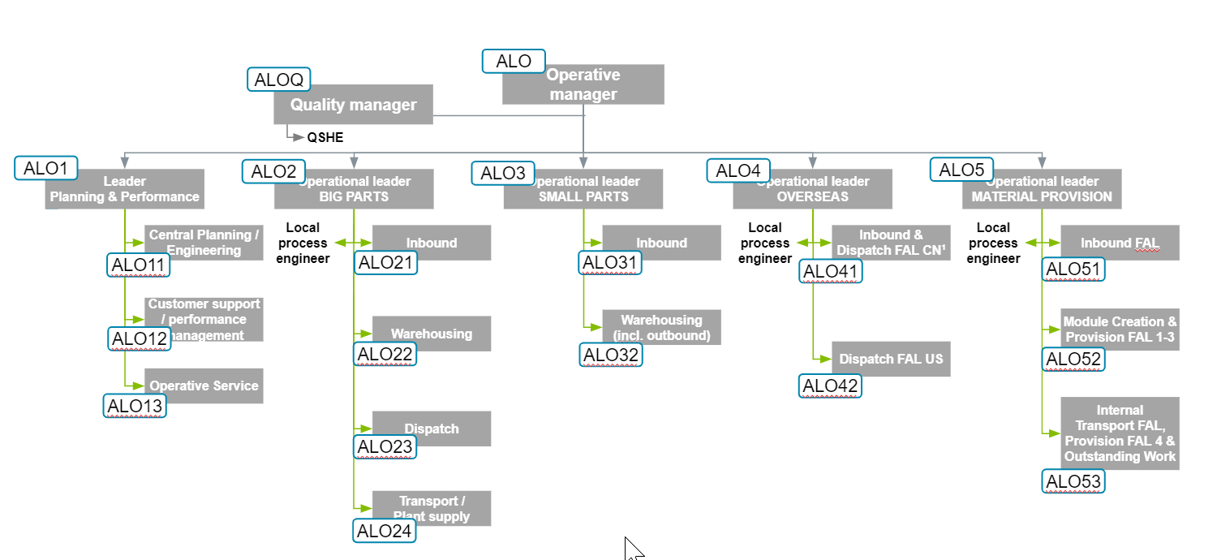

# ALA – Airbus Logistik Administration (Head of Administration)

## Role Purpose

The Head of Administration leads a central department dedicated to Airbus Logistik HR, Finance and corporate activities including topics managed though Service Level Agreements with Airbus Operations.

## Accountabilities and Missions

* Finance: cover all necessary financial functionalities and services in alignment with Airbus functions through SLA
* Human Resource: cover all necessary HR functionalities and services (including payroll) in alignment with Airbus functions through SLA
* Central Administration including requirements to Affiliates (based on A1043)
* Manage and Maintain Service Level Agreements with Airbus Operations
* Support to the Managing Director for corporate governance and shareholder meeting preparation

## Deliverables

Finance deliverables:

* Accounting and Reporting
* Asset Accounting
* Accounts receivables
* Account payable (invoicing)
* Treasury and cash management
* Tax management
* Insurance
* Support from Central Customs
* Travel and employee reimbursement

HR deliverables:

* HR business partner
* Payroll services, wage and bonus coordination
* Recruiting and Mgt. of Temporary Employment
* Labour law and social relations
* Training management
* Apprentice management
* MyPulse service

A1043 deliverables:

* Legal and compliance
* Enterprise Risk Management
* Deliverables covered by ALO function

SLAs:

* Central SLA covering Finance, HR and IT
* General Procurement SLA
* Airbus Operations SLAs covering:

## Organization Chart

The ALA Organization is a flat team structure covering

* Finance: represented by a “Head of Finance” inside the ALA organization working with Airbus Finance faculties through SLA (see below)
* HR: key responsibilities “HRBP” (HR Business Partner) and Payroll are managed by team members, the remaining services are covered through an SLA
* Management of A1043 requirements and overall SLAs are managed by Head of ALA in alignment with AL GmbH functions

## Interfaces

Interfaces with the main functions are governed by SLAs. A regular meeting governance will be established for start of operations.

# Support Functions

Main support functions for Airbus Logistik GmbH are provided by Airbus through Service Level Agreements. Airbus dedicated Functions plan and ensure continuous support according to these agreement

By nomination central Airbus Operations advisors (e.g. Safety at Work, Medical Services) act, survey and interface with Airbus Logistik personnel on behalf of the Managing Director (AL)

# Referenced Documents

| Doc. Reference | Title |
| --- | --- |
| [A1043](http://eds.eu.airbus.corp:8002/WorkplaceDMS/ECMLogicalURL?ECMObjectStore=Airbus&ECMSearch=EDSStandardSearch2&Ref=A1043&Status=Released&DocFormat=02&Launch=Y&ECMOperation=OpenDoc) | Requirements for Airbus Affiliates |
| [A30](http://eds.eu.airbus.corp:8002/WorkplaceDMS/ECMLogicalURL?ECMObjectStore=Airbus&ECMSearch=EDSStandardSearch2&Ref=A30&Status=Released&DocFormat=02&Launch=Y&ECMOperation=OpenDoc) | Production Organization Manual (POM) |
| [A30_Appendix C](http://eds.eu.airbus.corp:8002/WorkplaceDMS/ECMLogicalURL?ECMObjectStore=Airbus&ECMSearch=EDSStandardSearch2&Ref=A30_Appendix%20C&Status=Released&DocFormat=02&Launch=Y&ECMOperation=OpenDoc) | Airbus Capability List |
| [A30_Appendix E](http://eds.eu.airbus.corp:8002/WorkplaceDMS/ECMLogicalURL?ECMObjectStore=Airbus&ECMSearch=EDSStandardSearch2&Ref=A30_Appendix%20E&Status=Released&DocFormat=02&Launch=Y&ECMOperation=OpenDoc) | POA Nominees |
| [A10-AL_Appendix A](http://eds.eu.airbus.corp:8002/WorkplaceDMS/ECMLogicalURL?ECMObjectStore=Airbus&ECMSearch=EDSStandardSearch2&Ref=A10-AL_Appendix%20A&Status=Released&DocFormat=02&Launch=Y&ECMOperation=OpenDoc) | Airbus Logistik GmbH- Quality Plan for Airbus SAS POA Activities |

# Glossary

Always refer to LEXINET

|  |  |
| --- | --- |
| ACT | Aircraft Center Tank |
| AL | Airbus Logistik GmbH |
| ALA | Airbus Logistik Administration |
| ALO | Airbus Logistik Operations |
| ALOQ | Airbus Logistik GmbH Quality Organization |
| BMS | Business Management System |
| COO | Chief Operating Officer |
| F4 | EASA Form 4 |
| FAL | Final Assembly Line |
| KPI | Key Performance Indicator |
| PMT | Process Management Team |
| POA | Production Organization Approval |
| POM | Production Organization Manual |
| PPS | Practical Problem Solving |
| QMT | POA Quality Managers |
| QMTL | Logistics Quality in Airbus SAS |
| SA | Single Aisle |

1. Airbus Logistik GmbH- Quality Plan for Airbus SAS POA Activities

See [A10-AL_Appendix A](http://eds.eu.airbus.corp:8002/WorkplaceDMS/ECMLogicalURL?ECMObjectStore=Airbus&ECMSearch=EDSStandardSearch2&Ref=A10-AL_Appendix%20A&Status=Released&DocFormat=02&Launch=Y&ECMOperation=OpenDoc)

# Contributors

| Name | Function |
| --- | --- |
| Stephan Ohlerich | WP Leader Finance |
| Janine Arciszewski | WP Leader Operating Model |
| Dennis Kröger | WP Leader Quality |
| Laurence Lageyre | HO Quality Logistics |
| Matthias Weinhausen | Quality Manager ALOQ |
| Sabrina Oest | Quality Manager ALOQ |

# Record of Revisions

| Issue | Date | Reasons for Revision |
| --- | --- | --- |
| A | Dec 2021 | Initial issue. |

This document and all information contained herein is the sole property of AIRBUS S.A.S. No intellectual property rights are granted by the delivery of this document or the disclosure of its content. This document shall not be reproduced or disclosed to a third party without the express written consent of AIRBUS S.A.S. This document and its content shall not be used for any purpose other than that for which it is supplied. The statements made herein do not constitute an offer. They are based on the mentioned assumptions and are expressed in good faith. Where the supporting grounds for these statements are not shown, AIRBUS S.A.S. will be pleased to explain the basis thereof.